Masks Off, Rights On Social Toolkit

Our communities are under threat. ICE and other federal agencies are deploying masked, unidentified operatives into our streets, schools, and neighborhoods—sowing fear and chaos under the guise of law enforcement. These actions harm our communities and make us all less safe. We’re demanding immediate action to rein in this abuse.

Use these graphics and sample posts below to talk about this issue in your own voice. The goal of our social media efforts is to:
- Drive overall awareness and engagement for the goals of the campaign
- Encourage audiences to contact their legislators and demand action to unmask ICE
- Direct audiences to share their stories and personal experiences with ICE using our story tracker

#MasksOffRightsOn Digital Days of Action: Post between December 8-12!

SOCIAL MEDIA
GRAPHIC AND VIDEO download | TAGGING + HASHTAGS
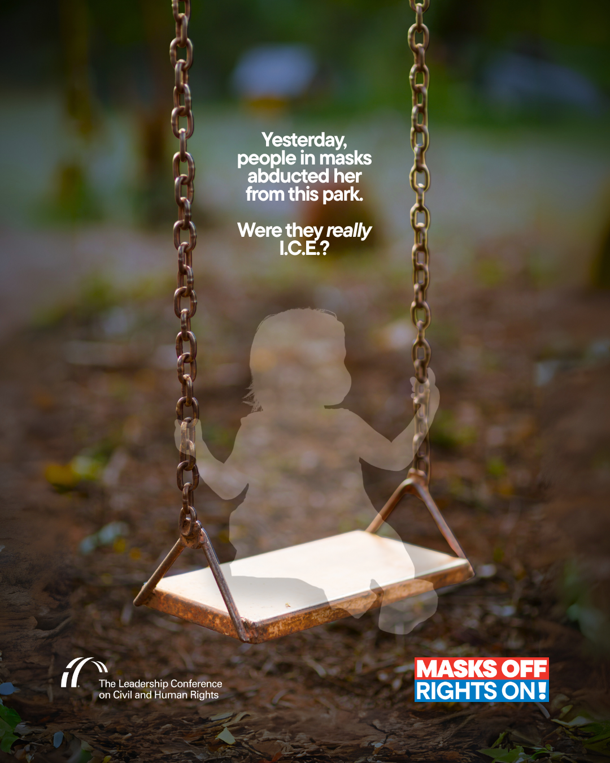  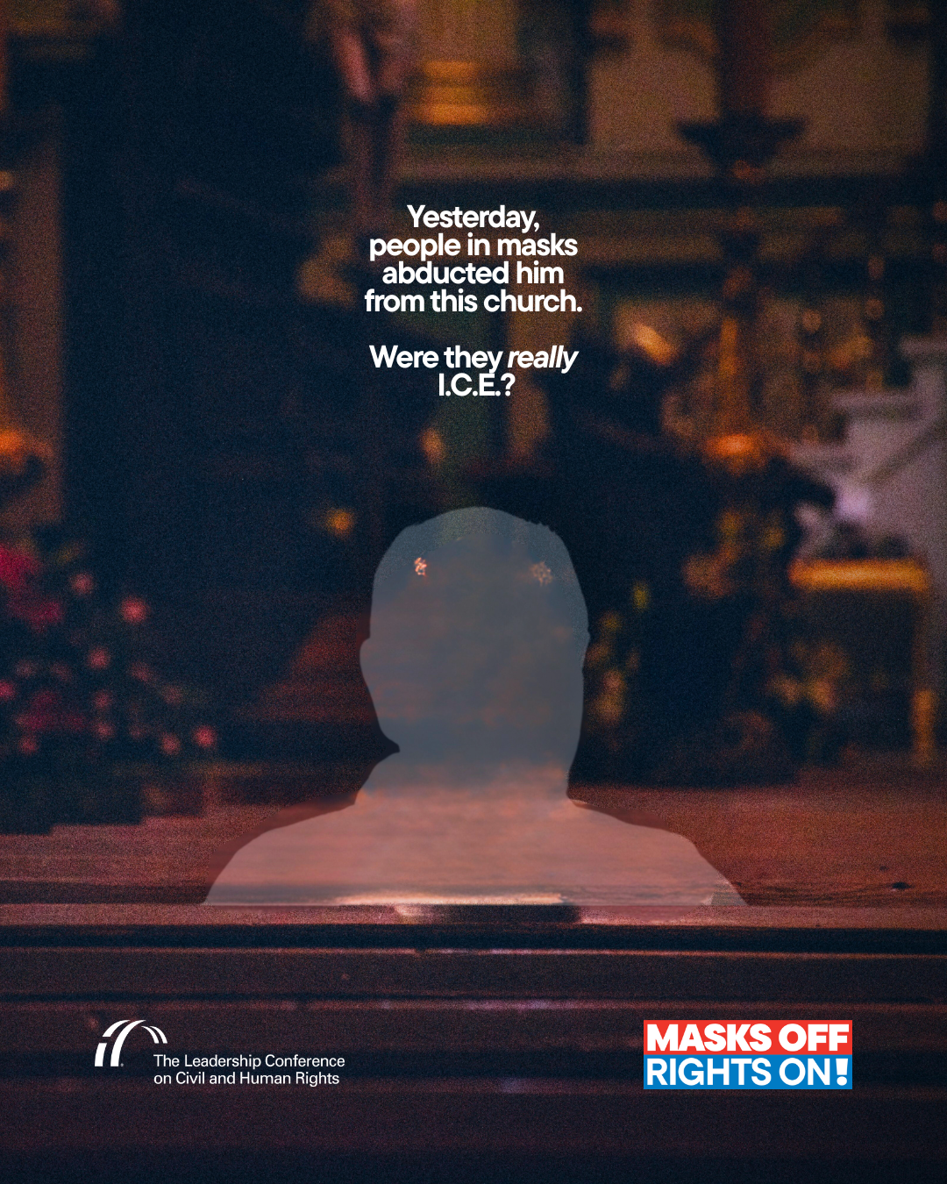 | Hashtags  - #MasksOffRightsOn
- Instagram: @civilrightsorg
- Facebook: The Leadership Conference on Civil and Human Rights
- BlueSky: @civilrightsorg.bsky.social
- X: @civilrightsorg
- TikTok: @civilrightsorg
- YouTube: The Leadership Conference on Civil & Human Rights

SAMPLE POSTS

Below you can find sample posts. Please feel free to edit the suggested language so it reflects your perspective and what matters most to your community.

X/BlueSky

- If “law enforcement” won’t ID themselves, anyone can put on a mask. 👤 It’s already happening: families robbed, assaulted, kidnapped by ICE impersonators.
Anonymous policing = danger for us all.
Tell Congress: unmask agents, protect rights 👉 #MasksOffRightsOn

- Masked men with guns ≠ safety. 🚫 Transparency = basic public safety. ✅
We should be able to send our kids to school without worrying that they might run into armed, unidentified agents! Demand accountability now: #MasksOffRightsOn

- School is a place for learning, not fear. ICE agents lurking around schools do not make our kids safe!
Time to stop the chaos and hold ICE accountable. Join us: #MasksOffRightsOn

- Anonymous, masked agents.
Militarized novices with minimal training.
Communities terrorized.
This isn’t law enforcement. It's an abuse of power, and we can’t stay silent. Use your voice 📢 #MasksOffRightsOn

Instagram/Facebook

- If law enforcement refuses to identify themselves, anyone can throw on a mask and pretend to be an officer.
It’s already happening: families robbed, assaulted, and kidnapped by ICE impersonators.
Anonymous policing is a danger to us all. Tell Congress to unmask these agents and protect our rights: #MasksOffRightsOn

- Masked individuals terrorizing our communities is NOT protection.
No parent should fear their child encountering armed, unidentified men on the way to school.
Transparency is basic public safety. Help us demand accountability and rein in this abuse: #MasksOffRightsOn

- No family should have to worry about ICE and masked federal agents lurking in schools, menacing children, or operating in secret. That’s not safety — it’s fear. It’s also civil rights abuse in plain sight.
Join us in taking immediate action to stop the chaos ICE is causing: #MasksOffRightsOn

- Anonymous, masked agents with no accountability.
Deputized novices with minimal training.
Communities terrorized.
This is not law enforcement. It’s a dangerous abuse of power, and we can’t stay silent. #MasksOffRightsOn

SPOTLIGHTING INAPPROPRIATE INCIDENTS

When videos of ICE agents making masked arrests circulate online, help us call them out by sharing the videos with commentary that emphasizes our message.

Example posts:

- Masked ICE agents are putting us all in danger by terrorizing communities and threatening safety.
Tell Congress:
#MaskOffRightsOn

- What is happening on our streets is a threat to all of our rights and safety. This must stop.
Tell Congress to take action now:
#MaskOffRightsOn

CONTACT YOUR REPRESENTATIVES
X/BlueSky
- Unidentified operatives with guns don’t belong in our neighborhoods or near our schools.

Our elected officials can stop this — but only if we take action. Contact your representatives and demand action:
#MasksOffRightsOn

Instagram/Facebook
- Unidentified operatives with guns shouldn’t be anywhere near our children, our neighborhoods, or our schools.

Our elected officials have the power to demand transparency and accountability — but they need to know this matters to their constituents.

Contact your representatives and demand they take action to protect our civil rights:
#MasksOffRightsOn

SHARE YOUR STORY
Instagram
- Have you witnessed ICE misconduct in your community? Your story could protect others.

@civilrightsorg is collecting eyewitness accounts of improper or illegal interactions with ICE agents to demand accountability and push for change. Share your story confidentially through their #MaskOffRightsOn campaign and help demand justice:

Facebook
- Have you witnessed ICE misconduct in your community? Your story could protect others.

The Leadership Conference on Civil and Human Rights is collecting eyewitness accounts of improper or illegal interactions with ICE agents to demand accountability and push for change. Share your story confidentially through their #MaskOffRightsOn campaign and help demand justice:

X/Bluesky
- Witnessed ICE misconduct in your community? Your story could protect others.

Share your account confidently and help demand justice:
#MaskOffRightsOn

